**Sikkim**

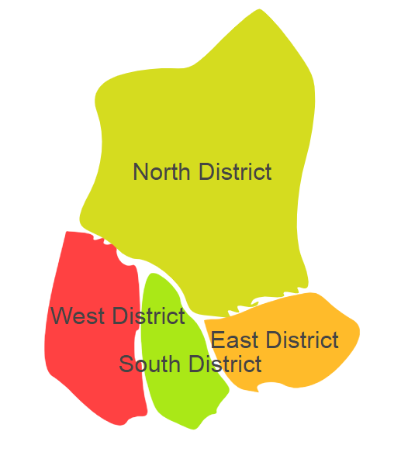

Sikkimcomprises of one Agro Ecological Regions (AER)16.

**Agro-Eco Region16:** AER16 in Sikkim comprises of East,North,South and Westdistricts of Eastern Himalayas under Agro-Ecological Sub Regions (AESR)16.2.